Electric Vehicle Revolution in India

Vinay Sharma
B.E.C.S.E
Chitkara university
Rajpura,punjab,India
vinay2529.be22@chitkara.edu.in
Vishal Kumar
B.E.C.S.E
Chitkara university
Rajpura,punjab,India
vishal2536.be22@chitkara.edu.in
Harsh Vardhan Singh
B.E.C.S.E
Chitkara university
Rajpura,punjab,India
harsh1627.be22@chitkara.edu.in

Abstract— India is seeing a slow transition to electric vehicles which at the same time is being left behind by the US, China and Norway which have seen great growth in EV’s because of aggressive policies and financial incentives. In this paper we look at the present state of electric vehicles in India. We cover government programs, market trends, issues and what the future holds. Also it is brought to light that in India two and three wheel electric vehicles are leading the pack which we put down to their lower price point and operating costs. That said we still see issues like lack of charging infrastructure, high initial outlay and dependence on import of batteries as barriers to growth. The paper puts forth that for the long term success we need to see ongoing policy support, growth in infrastructure and local battery production.

Keywords— Electric Vehicles, India, EV Adoption, Sustainability, Government Policy, Charging Infrastructure.

Introduction
The transport sector is a large player in global carbon emissions which we see to be about a quarter of the total. As urbanization plays out at a rapid rate and we see an increase in the use of personal vehicles we are also seeing a greater issue with air pollution and global warming. Electric vehicles (EVs) which include Battery Electric Vehicles (BEVs), Plug-in Hybrid Electric Vehicles (PHEVs) and Fuel Cell Electric Vehicles (FCEVs) put forth a better option to the traditional fuel -based cars. What we see is that EVs produce less emissions also especially when they run on renewable energy sources. In the case of India which is the largest auto market we see that there are large opportunities and also great challenges for the adoption of EVs. We are seeing that increasing fuel prices, pollution in metro areas and government policies are what is in large part bringing us towards a greater acceptance of electric mobility.

MARKET OVERVIEW

Current Market Status

The Indian EV market is growing at a fast pace and we see an annual increase in users. In millions of electric vehicles which are already on Indian roads we see that the market has really taken off. B. Segment-wise Distribution. Segment wise Distribution

The Indian EV market can be divided into a few segments:

Two-Wheelers: Bicycles:
This segment is at the head of the EV market due to lower price point, easy charging options, and use in daily commute. It is very much a part of the routine transport of middle and low-income citizens.

Three-Wheelers:
Electric go-karts are for short distance use and very much a part of the commercial market and also do not break the bank which is great for owners of small businesses.

Four-Wheelers:
This market which is a fast-growing segment at present has a small market share. Tata Motors and Mahindra and Mahindra are among large companies that are into EVs.

GOVERNMENT POLICY.

Government role and policies.
The Indian government plays a key role in the adoption of EV in many ways:
FAME Scheme: The underpinning Scheme which also puts in place financial incentives and supports growth of charging infrastructure. PLI Scheme: Drives up domestic production of EV components and batteries. Tax Incentives: EVs are a more affordable option because of lower GST, road tax, and registration fees. B. State Level Policies.

State-Level Policies
State governments provide a great deal of support in form of incentives and infrastructure. At the same time however due to variation between states in policy the market sees great difference in development.

Infrastructure Challenges
A. Charging Stations.

One issue with EV adoption is the lack of charging infrastructure. While we see an increase in the number of charging stations from what we had a few years back that is still not enough in terms of what we have today’s EV population. This issue of charging station availability includes many aspects which to look at:

Poor Equity: Charging infrastructure is present in urban areas which leaves rural and semi urban areas without it. This causes range anxiety for users. We also see that there are many charging stations which have slow or medium charge speed and very few that are fast. Home charging issues in many cases people do not have dedicated parking at home which is a issue in the urban settings in particular thus they are left to use public chargers which are in short supply.

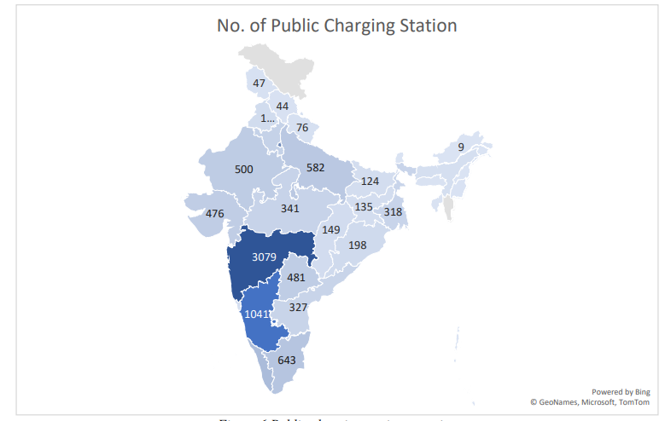

Problems with the Battery Supply Chain.

In the Indian EV market which the batteries and raw materials play a very key role in, we see that the risk is great in price fluctuation and in variation of stock supply across the globe. Also we have that there are very little of the key minerals which go into the making of the batteries present in India. Local production set up and going abroad for contracts is a time and money issue.

Consumer Adoption Motivators and Hurdles.

Adoption Influencing Factors. As it can be evidenced, EV adoption decisions are influenced in a different number of ways. Cores of purchase are comprised of performance expectancy, perceived cost-effectiveness, hedonic motivation particularly on two-wheeler purchasers [5]. It is the awareness of the environment. crucial factor, where consumers pay more attention to sustainability along with economic gains. The presence of rapid charging infrastructure has emerged as a tremendously significant contributes to purchase. intent, in which the consumers have adequate charging infrastructure demonstrating. a much higher tendency to EV adoptions [13]. The governmental support measures are. subsidy awareness and access, the adoption behavior is highly determined by them [14].

Unrelenting Barriers to Adoption. Despite the growing consumer interest, there are important impediments to quicker adoption: High Start-up Cost: Start-up costs of vehicles continue to be a significant issue among the customers. total cost of ownership advantages over ICE cars [15]. Options and indecisiveness in the financial institutions aggravate this limited consumer financing. Range Anxiety: Consumer problems through a single charge range: The issue of consumer concerns about the range remains, particularly passenger car markets [16]. With the development of the battery technology, there is a corresponding development in the other technology. relieving this, there is no problem with the range limitations in inter-city transportation. Insufficiency of Charging Infrastructure: The unavailability of charging infrastructure listed above. is a drastic impediment, particularly in the passenger car markets where the range anxiety encounters the absence of charging networks in the city [9]. The Problems of Maintenance and Service: Inaccessibility to special service facilities and tinged parts, particularly in smaller cities and rural areas, cause proprietary fear.

Environmental Perception Issues. The whole ecological footprint of the EVs remains a misconception. Although EVs are in a far better position than ICE cars due to lifecycle emissions, there are problems with electricity production. Areas that have to be covered include recycling of sources and battery. Resolving these perceptions. require tremendous facts on EV environmental benefits and life cycle. examination.

Technological and Manufacturing Improvement.

Production Abilities and Struggles. In the recent past, the production of EV in India has also increased tremendously. Competition opportunities lie in the use of innovative technologies of manufacturing, including automation and Industry 4.0 solutions. Modern manufacturing. has been applied and demonstrated the growth in the duration of production and quality of the products [18]. There are opportunities and challenges of workforce development. The upskilling programs are highly effective at enhancing the skills of employees in advanced manufacturing systems. Nevertheless, the acquisition of advanced manufacturing technologies remains a skill gap in the area of serious scopes [18].

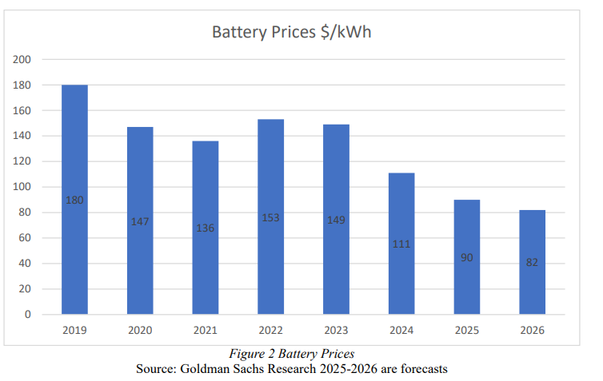

Battery Technology Innovations. Solar-powered charging infrastructure is a new technology that can have potential. such technology is a combination of two essential concerns: charging infrastructure and renewable energy [1]. Vehicle-to-Grid (V2G) technology which enables vehicles and vehicles to exchange energy in both ways. Introducing grid stability management and renewable energy opportunities, energy grids. Integration, although the regulatory frameworks were not developed in India [19]. Smart meters Smart grid systems that are implemented are renewable energy and responsive. Charging systems are also a viable basis of EV charging ecosystems [20].

Competitive Dynamics and Leaders in the market.

Leadership in the market at Tata Motors. According to its strength, first-mover advantages, strong brand loyalty, and closed ecosystem, Tata Motors has already established itself in the Indian EV market. The companies have enabled the Market with their EV portfolio models of various prices breakthrough across consumer segments [21]. Tata, which has been proven to operate based on innovation-based strategies and the creation of native technology provide it with strategic positioning.

New Competitors and New Market Entree. The EV market also diversifies rapidly. Novice venture-financed entrants focus their efforts on accessibility and affordability of the mass-market [21]. Traditional competitors like Mahindra. There are also other companies such as Mahindra, Maruti Suzuki and Hyundai which are progressively building their EVs portfolios and production capacity as the global competitors increase the intensity of competition.

Localization Strategy and Supply Chain.

Supply Chain Optimization. The EV supply chain in India is not well coordinated and fragmented and this limits coordination and quality management. Green initiative, waste, is a part of supply chain management practice in the area. The circular economy, circular economy management and principles are needed [1]. The resilience in the supply chain requires diversification in sourcing of raw materials, dependence on imports and expansion. local abilities of producing components. The second opportunity is located in the Import Substitution and Localization,

The import duty policies and structures promote domestic manufacturing. Nonetheless, it has a structural weakness [23] in the intensive use of imported parts. The strategic alliances, technology transfer deal and in-country research and development on the most modern battery chemistry and motor technologies are expected to be given priority to form long term.

competitive advantages.

Environmental and Social Trajectories. Emission Reduction Emission Reduction The emission reduction potential (ERP) is defined by Emission Reduction Potential. The EVs will possess high environmental impacts due to reduced tailpipe emissions. and reduced air pollution. The co-benefits also include improved air quality in the cities having an electrified public transportation and reduced fuel import payments and creation of green work opportunities. Development of the EV manufacturing sector, Infrastructure development, and services connecting to it is a noteworthy aspect. of the transition.

Environmental Lifecycle. The environmental assessment must be comprehensive that incorporates the lifecycle. and including manufacture of batteries, production of electricity and end-of-life management of batteries. The EV lifecycle emissions are already at a much lower level than the ICE vehicles despite the consideration. current electricity generation mixes, means of additional environmental improvement. require even more of renewable energy infiltration, successful battery production, and intensive. recycling systems [17].

Strategic Pathways and Recommendations.

Fast growing networks of charge points are a result of public and private sector partnerships which also include government and commercial investment. We should see a great deal of investment in high speed networks along inter city routes which in turn will cluster around renewable energy sources.

Smart Grid Integration: we are putting in place smart charging and Vehicle-to-Grid systems which in turn will improve grid performance. Also, we are seeing to it that there is consistency in policy across central and state governments to thus increase investor confidence in local safety standards and large scale infrastructure projects. Financing and Incentive Structures: we are to create new finance models like battery leasing, extended bonus which target certain consumer groups and tax breaks which grow with EV adoption.

Supply Chain Localization Domestic Battery Manufacturing: we must very quickly develop our own battery gigafactories which also puts a great effort into better technology which in turn will reduce import reliance. Raw Material Security: we are to form strategic relationships for the source of key minerals via collaboration in exploration, recycling and research into alternatives.

Demand Generation and Consumer Involvement: Public Information Campaigns: we put out programs which will do away with misconceptions of EVs and will put forward their environmental benefits, life cycle advantages and total cost of ownership. Consumer Financing Programs: we are to work with financial institutions to design EV specific financing products with very good terms which will in turn make EV’s more affordable to middle income consumers.

Prognosis and Rough Estimation of Development.

Market Projections EV market is projected to grow in the future in India in a tremendous way [29]. Nevertheless, in order to achieve high ambitions, it will be required to have greater adoption rates and longer-term policy. support.

Segment-wise Growth Projections reveal that electric vehicles will occupy the large shares through all vehicles by 2030 [30]. This discontinuous growth course signifies. the various types of vehicles in the facility where they are the singularly available and beneficial ones. Socio-economic situation in India [4].

Technology Evolution New technology and innovations like new battery chemistries, solid-state batteries, hydrogen fuel cells, and self-driving electric vehicles are likely to change the competitive. landscape. Policymaking structures and R&D. investments made the manufacturing strength in India, which allows the country to participate in the next-generation technology adoption [31]. Conclusion India electric vehicle revolution is an important transition of the Indian nation. the transportation industry, which is driven by the intersection of interest of environmental sustainability, energy security, and economic change. The market has reached a great level compared to the nascent inception which demonstrates the viability of the policy frameworks and market in India. readiness [1]. However, the way to the achievement of 2030 targets is not smooth. The government industry, coordinated effort and financial sectors must work on critical infrastructure improvement, particularly charging systems, supply chain localization and so forth. consumer financing. The specificities of the Indian market which is dominated by two and three wheelers, spread over geographically and economically heterogeneous- demand. localized solutions which are not comparable to global patterns of EV adoption [30]. The possibility to speed up EVs uptake will rely on remaining on track with the policy and investing. considerably in charging and clean energy infrastructure, development of local battery. manufacturing capabilities, and address the problem of cost with ingenuity. f systems of funding and subsidization. India will soon turn into transformational nation. change of mobility, alignment of stakeholder and concerted execution of holistic. policies will determine the success of the nation in its high aspirations and positions. it is a leader in sustainability in transportation.

SUPPLY CHAIN AND LOCALIZATION

- Supply Chain Challenges

The EV supply chain is disjointed and needs more coordination and sustainability endeavors.

- Localization Efforts

The government programs are meant to minimize the importation reliance by introducing manufacturing and developing the technology within the country.

Impact of the COVID-19 Pandemic.
We see that there were three main stages of adoption which played out. First was the early adoption phase up to 2020 which saw two wheelers go from 19,333 units in 2019 to 1,52,000 units in 2020 that is an 685% rise as per figure 4. Three wheelers grew more moderately from 1,26,000 to 1,40,000 which is an 11% increase and four wheelers which basically stayed the same at 3600. Despite the break out of the COVID-19 pandemic what is striking is the large-scale adoption we saw in two wheelers in 2020 which indicates large scale latent demand for affordable last mile electric mobility solutions. Usually requiring lower initial investment and simple deployment for daily commutes two-wheeler EV’s mostly play in the commercial space of last mile delivery and shared rides. Three wheelers did see some growth but was limited by initial driver resistance and regulatory issues. Also in the second stage which was the pandemic impact and consolidation 2020-2021 we saw two-wheeler segments drop to 1,43,000 which is a 6% decrease from 2020 and three wheelers went down to 88,00 which is a 37% drop also four wheelers saw a small increase to 5,905. Overall sales went down during this phase which was a 20% drop from 2020. The dip in 2021 is a result of manufacturing shut downs, supply chain issues for lithium-ion cells and also consumer hesitation. Two and three wheelers were hit the hardest as many users faced economic instability. In the third stage which was the accelerated growth phase 2021-2023 we saw sales of two wheelers go up to 2,52,539 in 2022 and then to 7,20,733 in 2023 that is an 185% rise.
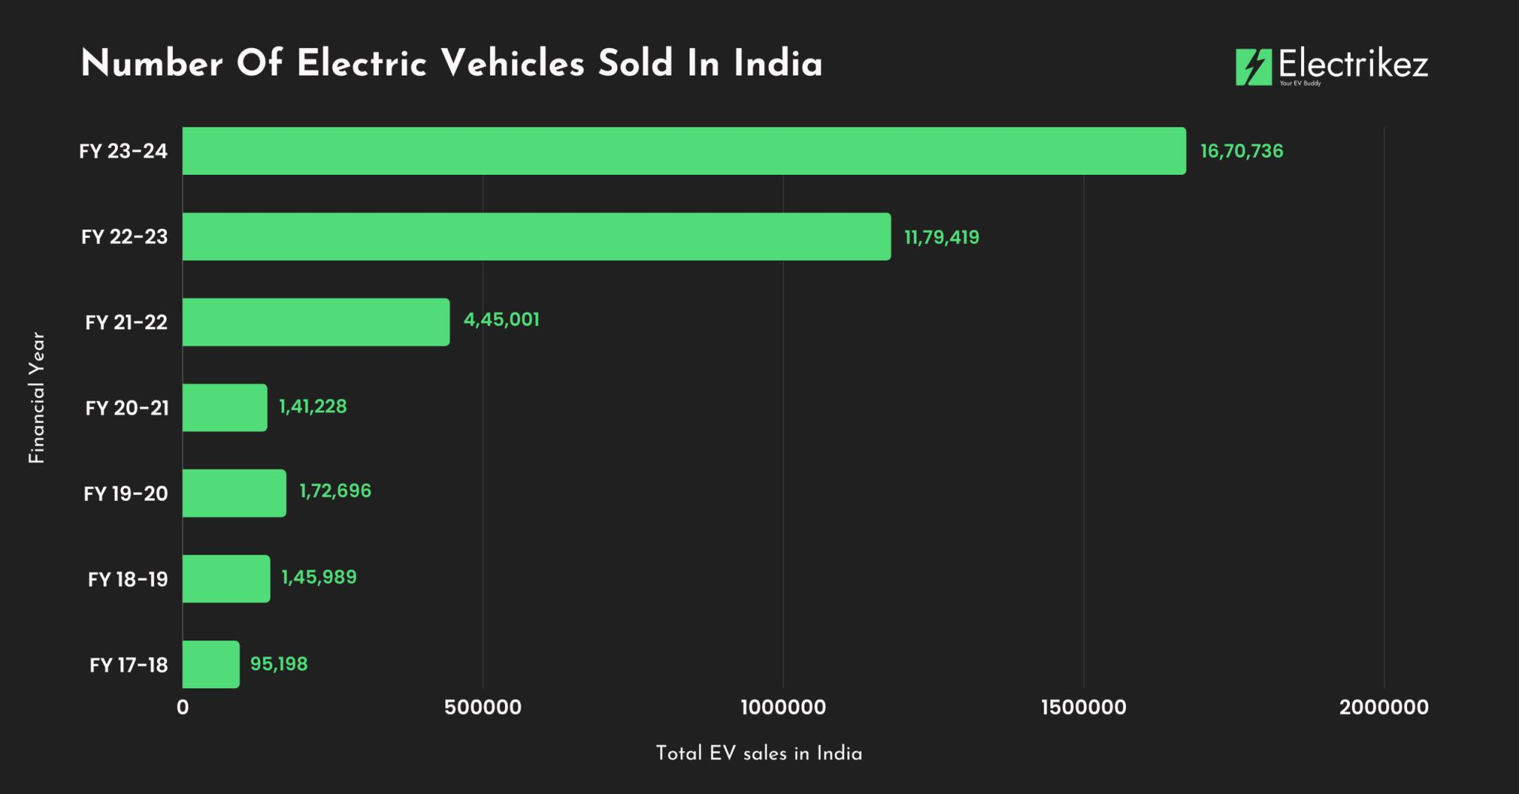

In the 2022 the three wheeler segment saw a return to 1,88,447 and then to 3,99,549 in 2023 which is a 112% increase and in four wheelers we saw sales go up to 21,00 in 2022 and then to 53,843 in 2023. As a whole sale during that time frame grew from 2,365,905 in 2021 to 4,61,986 in 2022 and further to 11,74,116 in 2023. Two wheelers took the lead because of the large scale introduction of new models by manufacturers, the drop in battery prices, and the growth of financing options like EMI schemes. The economic upturn which came after the lockdown was very much in play for three wheelers which are used for in city last mile logistics and shared mobility. They found electric vehicles to be a good business play because of the low operating costs. Although they were in a smaller number at base, four wheelers saw a 15 fold increase from 2019 to 2023 which indicates that customers’ confidence in personal electric.

Evolving Consumer Preferences
Understanding the consumer base is key to the future of the EV market in India. We see that they put forth what are the main factors which play into consumer purchase intent which are environmental issues, battery performance and the availability of charge points. Also they reported on the issue of high initial outlay and low range which we must address.

Also, from the work of Sharma et al. (2021) we see that what he terms as perceived benefits like lower operating costs and environmental Good which do in fact influence the adoption of EVs. That said we still see large scale adoption is being held back by a lack of information and EV performance and reliability issues.

Methodology
The adoption and development of EVs show great promise in the Indian setting, where worries over energy security, growing vehicle pollution, and rising urbanization are prevalent. But this change comes with a host of difficulties that are specific to the Indian context in terms of legislation, technology, infrastructure, and socioeconomic issues. The data used in this paper was collected from various official and publicly available secondary sources. of operational PCS across India was obtained from the Bureau of ee and recent government reports on EV infrastructure. The timeline for the government policy is 2013 to 2024 in which information on major government policies and schemes related to electric mobility was collected. Next the state wise data of public charging stations were gathered in which no. So majorly the sources of data are government reports, VAHAN database, SMEV annual reports and IEA. This paper applies simple descriptive methods to analyze the data. For the trend analysis EV sales figures from 2019-2023 were presented to observe annual growth in different segments and sales pattern were compared before and after the introduction of major policies. Then for policy correlation qualitative observation by aligning the timeline of policy introduction with EV sales trends, we observed how each policy appears to have influenced market growth and although no statistical testing was done, visual inspection helped identify periods of significant change. This helped in identifying which states have developed strong charging infrastructure and which are lagging.

Limitations
In this study we used a non-probabilistic purposive sampling which we did in very specific geographical clusters and we did not do KIIs in all companies which is why we can’t present the results as a whole picture of what is going on in all Indian auto clusters. We see that our results don't play out for what the down-stream stakeholders report as transition issues and opportunities. We found that we only got back 50% of the responses we sent out (to a total of 116) which may have introduced participation bias into our results. Some large-scale companies did not partake in this study because they have many internal protocols and time-consuming data sharing processes which they had to go through. We had start-up
companies which did not participate due to their own data sharing policies. Although we recognize that this is a key element in a just transition-n we had to focus at the enterprise level which is why we did not look at this issue in detail.

Data Analysis and Interpretation:
Demographic Analysis: Population Study:

Age: The large majority of respondents (60.3% were in the 25 to 45 year range (χ² 10.23, p 0.01).

Gender: Males made up 71.5% of the respondens(χ² 4.56, p 0.05).

Education: 63.6% of respondents had a post graduate degree (χ² 12.12, p 0.01).

Income: 55.6% of respondents reported an annual income over of Rs.5,00,000 (χ² 8.45, p 0.05).

Factors Influencing EV Adoption:

Environmental Concerns: In that which we surveyed 72.2% reported environment issues to be a key factor in their decision (χ² 25.12, p 0.01).

Government Incentives: On government incentives we saw that 65.6% think these greatly promote EV adoption which was significant (χ² 20.56, p 0.01).

Range Anxiety: For range anxiety we noted that 55.6% put this forward as a large issue (χ² 18.56, p 0.01).

Perceived Benefits:

Environmental Benefits: 85.4% agreed EVs offer environmental advantages (χ² = 30.12, p < 0.01).

Lower Operating Costs: 76.1% believed EVs have lower running costs (χ² = 22.45, p < 0.01).

Perceived Barriers:

High Upfront Cost: 62.2% identified cost as a major barrier (χ² = 18.56, p < 0.01).

Charging Infrastructure: 58.9% highlighted lack of infrastructure (χ² = 15.67, p < 0.01).

Policy Suggestions:

Improved Incentives: 70.2% suggested enhancing government incentives (χ² = 20.56, p < 0.01).

Infrastructure Investment: 63.6% recommended more investment in charging infrastructure (χ² = 18.56, p < 0.01).

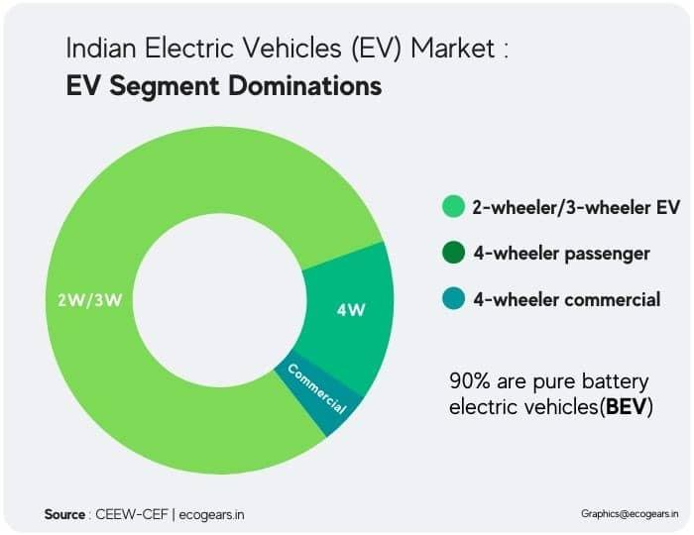

Future research
Projections are that in the long term India will see growth in electric vehicles which will be supported by many factors:
- Increased growth of charging and swap networks.
- Also reporting on the progress of battery tech.
- Run campaigns to increase public awareness of environmental issues.
- Governmental efforts to increase EV adoption.
- By 2030 India aims to be a world leader in EV penetration which will position the country to take the lead in the space.

FINAL Conclusion
India is taking a great step forward with its push into electric vehicles which is a element of sustainable growth. We have seen great growth in this area but we still have issues which we must address. We must improve infrastructure for charging, reduce prices, and increase public awareness to see greater adoption. Government, industry and consumer groups will have to work together to position India as a global leader in electric mobility.

References

- NITI Aayog, “Electric Vehicles in India: Policy and Market Analysis,” Government of India, 2025.
- India Brand Equity Foundation (IBEF), “Electric Vehicle Industry in India,” 2025.
- Institute for Transportation and Development Policy (ITDP), “Accelerating Charging Infrastructure for India’s Electric Future,” 2025.
- Mordor Intelligence, “India Electric Vehicle Charging Station Market Size and Forecast (2025–2030),” 2025.
- EV Reporter, “Charging India’s EV Revolution: Infrastructure and Demand Analysis,” 2026.
- [9]. Electric vehicle charging – Global EV Outlook 2025 – Analysis. (n.d.). IEA. Retrieved May 27, 2025, from
- https://www.iea.org/reports/global-ev-outlook-2025/electric-vehicle-charging
- Electric Vehicles: Electric Vehicle Industry in India and its Growth. (n.d.). India Brand Equity Foundation. Retrieved May 26, 2025, from https://www.ibef.org/industry/electric-vehicle
- EVO Report 2024 | BloombergNEF | Bloomberg Finance LP. (n.d.). BloombergNEF. Retrieved May 13, 2025, from https://about.bnef.com/electric-vehicle-outlook/
- Fame II | Ministry of Heavy Industries. (n.d.). Retrieved April 23, 2025, from https://heavyindustries.gov.in/fame-ii
- FAME PHASE-II SCHEME. (n.d.). Retrieved June 11, 2025, from https://www.pib.gov.in/www.pib.gov.in/Pressreleaseshare.aspx?PRID=2102782
- Global EV Outlook 2023 – Analysis. (2023, April 26). IEA. https://www.iea.org/reports/global-ev-outlook-2023
- ICRA Limited. (n.d.). Retrieved May 26, 2025, from https://www.icra.in/Research/AllResearchReports?isSpecialComments=false
- Incentives and Legislation | European Alternative Fuels Observatory. (n.d.). Retrieved May 27, 2025, from https://alternative-fuelsobservatory.ec.europa.eu/transport-mode/road/germany/incentives-legislations
- India Leaps Ahead: Transformative Mobility Solutions for All. (n.d.). RMI. Retrieved June 4, 2025, from https://rmi.org/insight/indialeaps-ahead-transformative-mobility-solutions-for-all/
- Light-duty vehicles—European Commission. (n.d.). Retrieved May 27, 2025, from https://climate.ec.europa.eu/eu-action/transportdecarbonisation/road-transport/light-duty-vehicles_en
- Mapping India’s Energy Policy 2022 | International Institute for Sustainable Development. (n.d.). Retrieved May 26, 2025, from https://www.iisd.org/publications/mapping-india-energy-policy-2022
- Ministry of Industry and Information Technology of the People’s Republic of China. (n.d.). Retrieved May 27, 2025, from https://www.miit.gov.cn.

